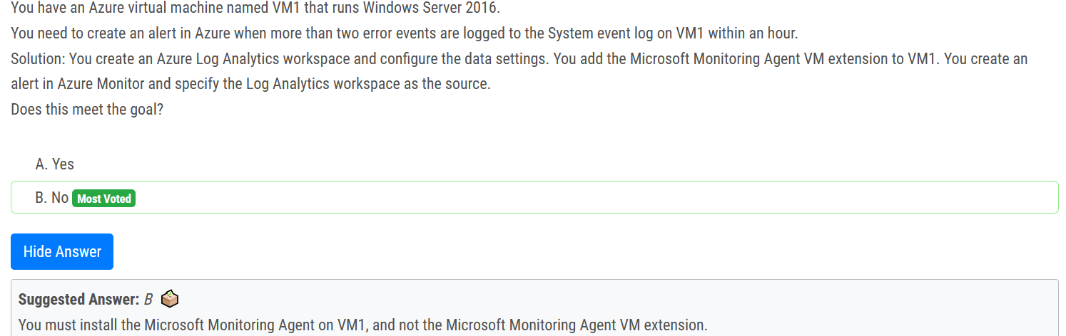

You add the Microsoft Monitoring Agent VM extension to VM1 > This is WRONG

You Install the Microsoft Monitoring Agent VM agent to VM1 > This is Correct

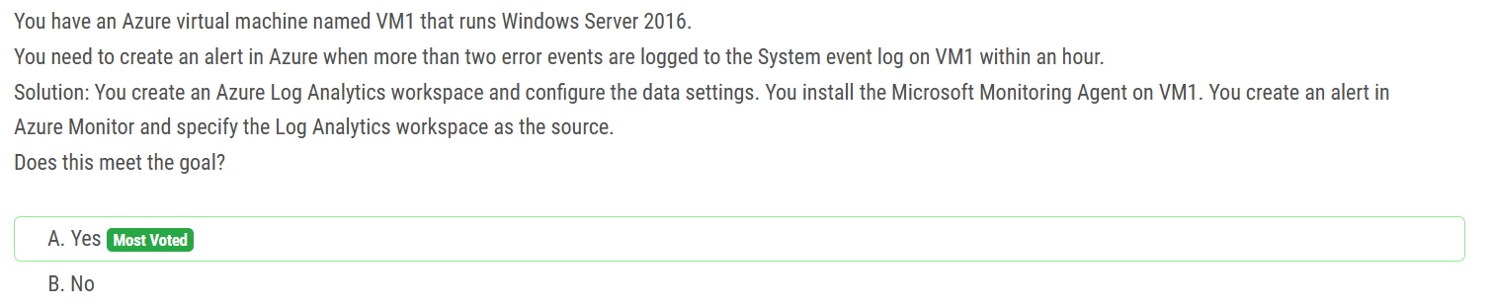

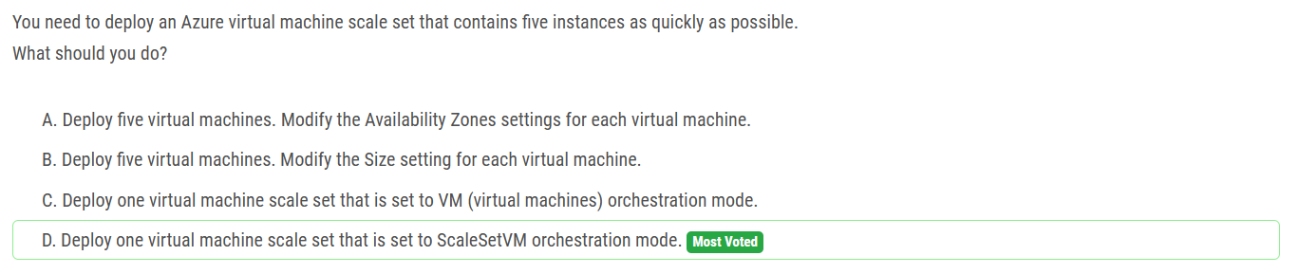

Currently the correct option is the Uniform Orchestration Mode

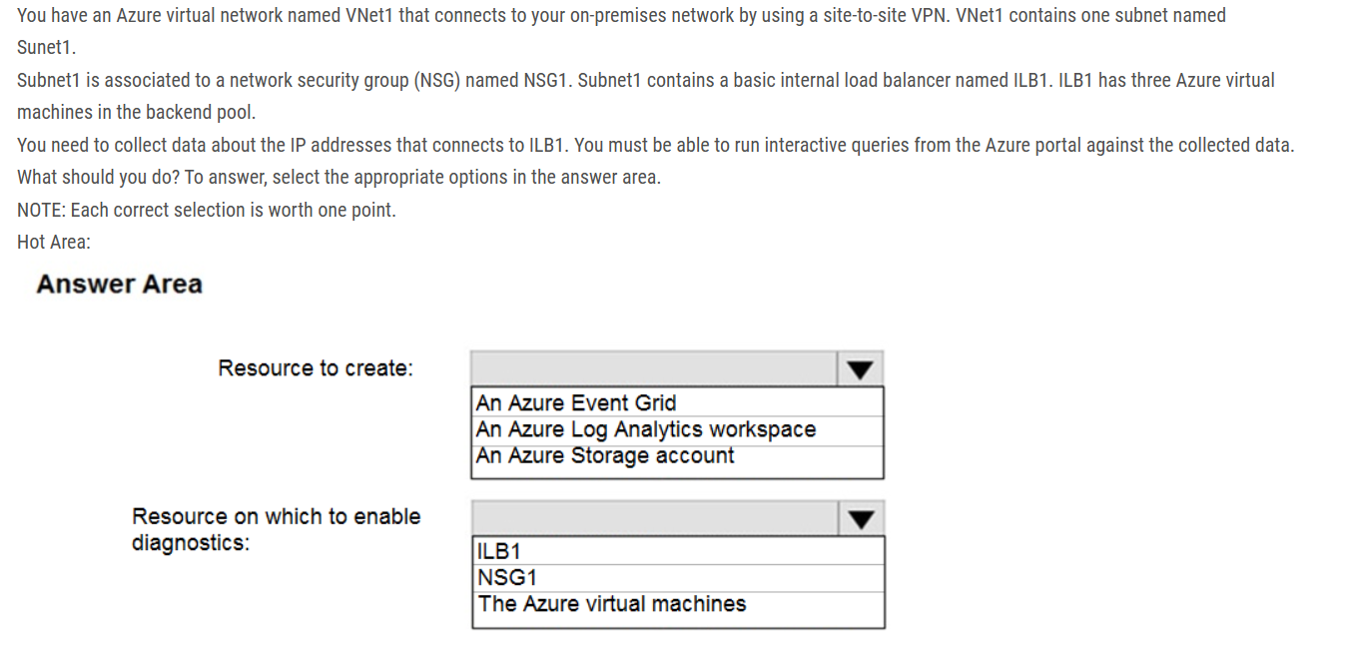

Box 1: An Azure Log Analytics workspace In the Azure portal you can set up a Log Analytics workspace, which is a unique Log Analytics environment with its own data repository, data sources, and solutions.

Box 2: NSG1 NSG flow logs allow viewing information about ingress and egress IP traffic through a Network security group. Through this, the IP addresses that connect to the ILB can be monitored when the diagnostics are enabled on a Network Security Group. We cannot enable diagnostics on an internal load balancer to check for the IP addresses.

As for Internal LB, it is basic one. Basic can only connect to storage account. Also, Basic LB has only activity logs, which doesn't include the connectivity workflow. So, we need to use NSG to meet the mentioned requirements.



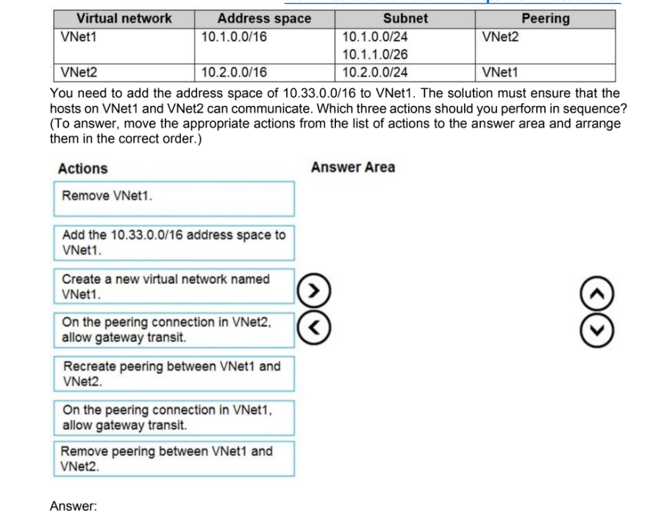

Step 1: Remove peering between Vnet1 and VNet2.  
You can't add address ranges to, or delete address ranges from a virtual network's address space once a virtual network is peered with another virtual network.  
To add or remove address ranges, delete the peering, add or remove the address ranges, then re-create the peering.  
Step 2: Add the 10.44.0.0/16 address space to VNet1.  
Step 3: Recreate peering between VNet1 and VNet2

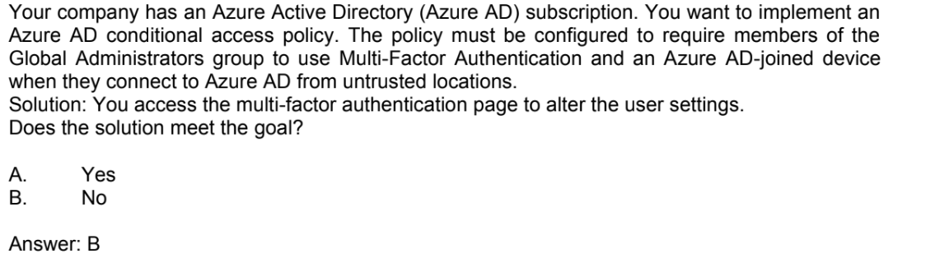

You access the Azure portal to alter the grant control of the Azure AD conditional access policy.

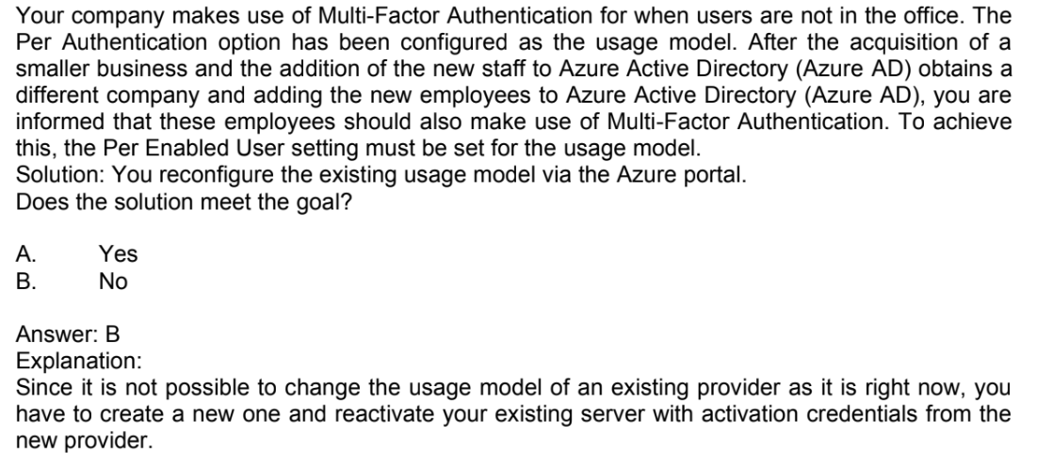

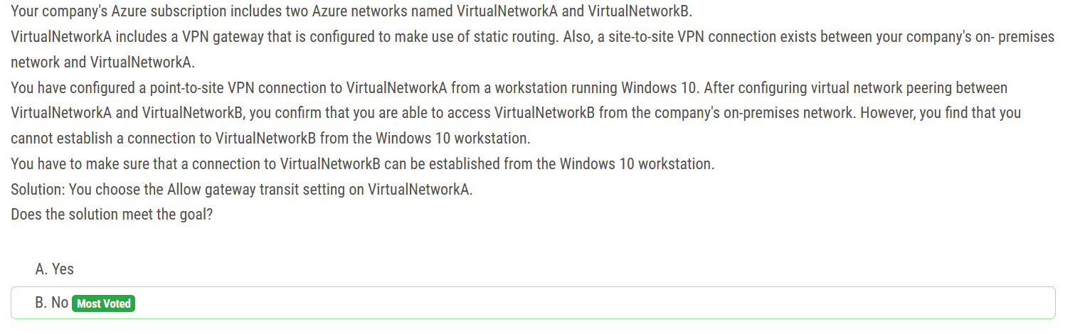

If you make a change to the topology of your network and have Windows VPN clients, the VPN client package for Windows clients must be downloaded and installed again in order for the changes to be applied to the client.

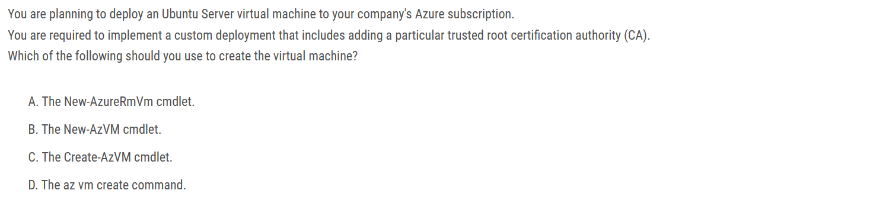

The answer is D. The az vm create command. The az vm create command is the most flexible way to create an Azure virtual machine. It allows you to specify a wide range of options, including the trusted root CA. The New-AzVM cmdlet is also a good option, but it does not allow you to specify the trusted root CA. The New-AzureRmVm cmdlet is deprecated and should not be used. The Create-AzVM cmdlet is a wrapper for the az vm create command, so it is not as flexible.

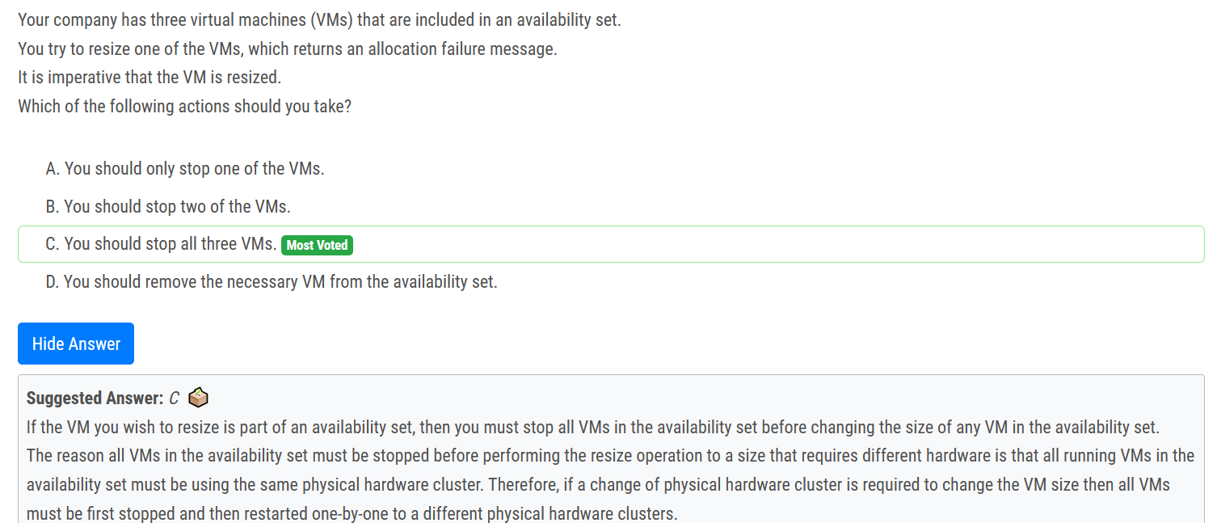

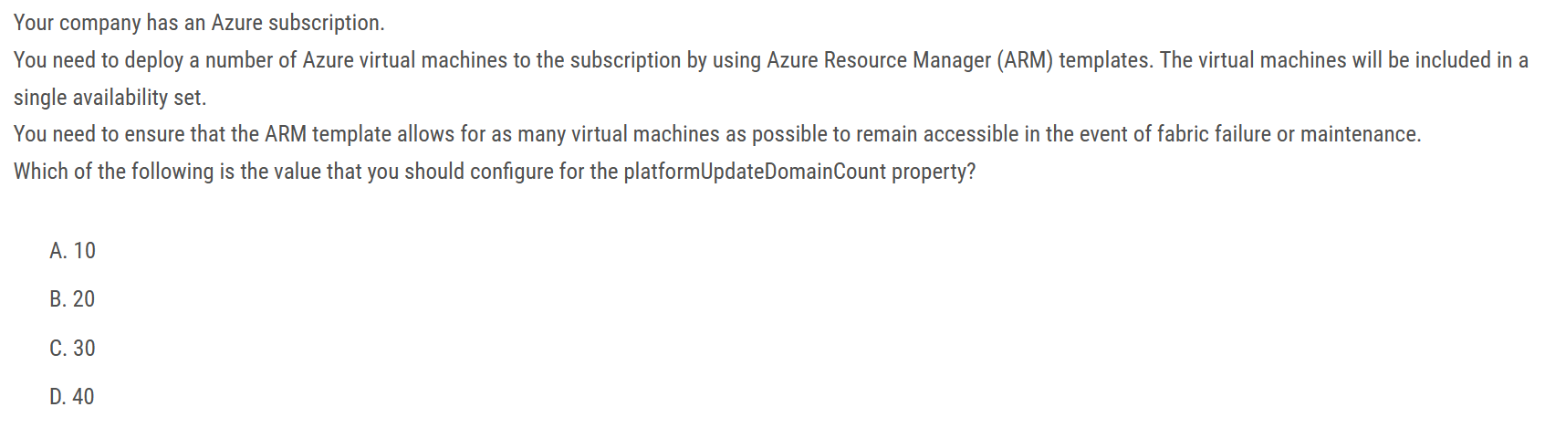

Answer is B 20

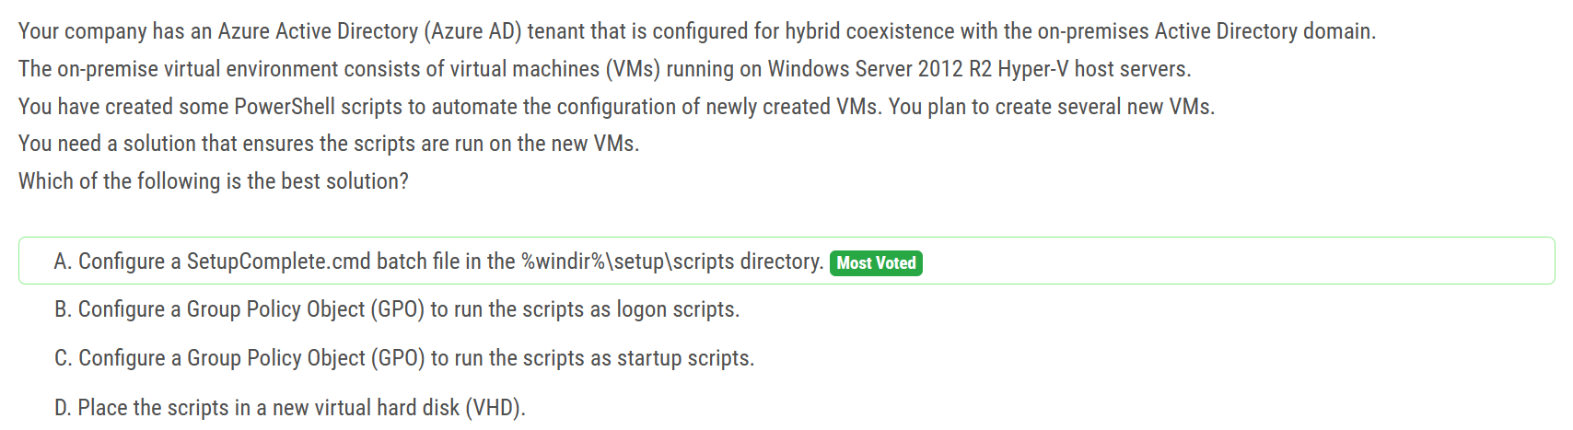

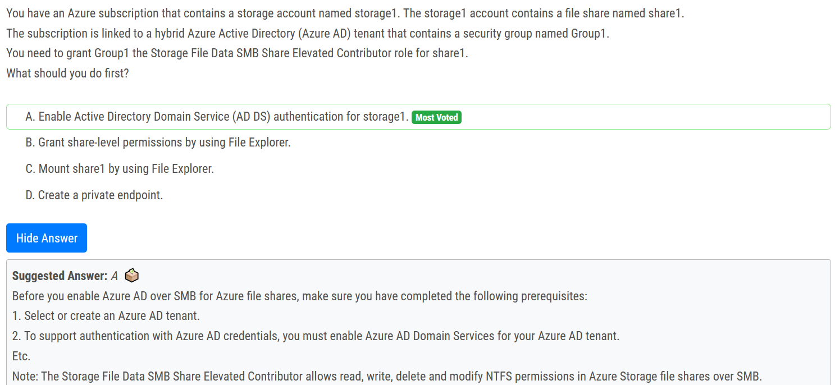

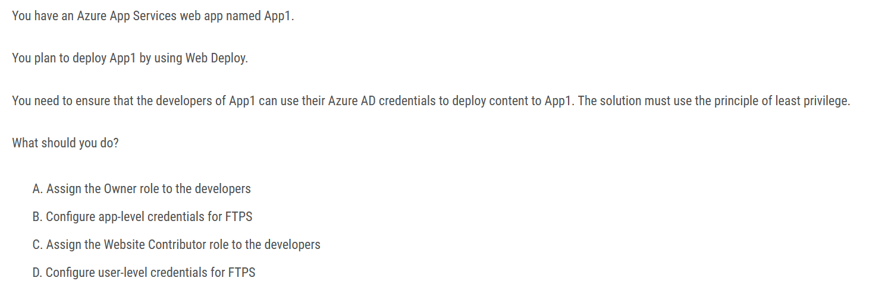

Ans: C.

Assign the Website Contributor role to the developers. To allow the developers of App1 to use their Azure AD credentials to deploy content to App1 using Web Deploy, you should assign the Website Contributor role to the developers. This role provides the necessary permissions for developers to deploy content to the web app, but does not grant them excessive permissions that could be used to make unwanted changes.

Option B and D are not relevant to the scenario as the question is specifically asking for how to use Azure AD credentials for Web Deploy, not FTPS.

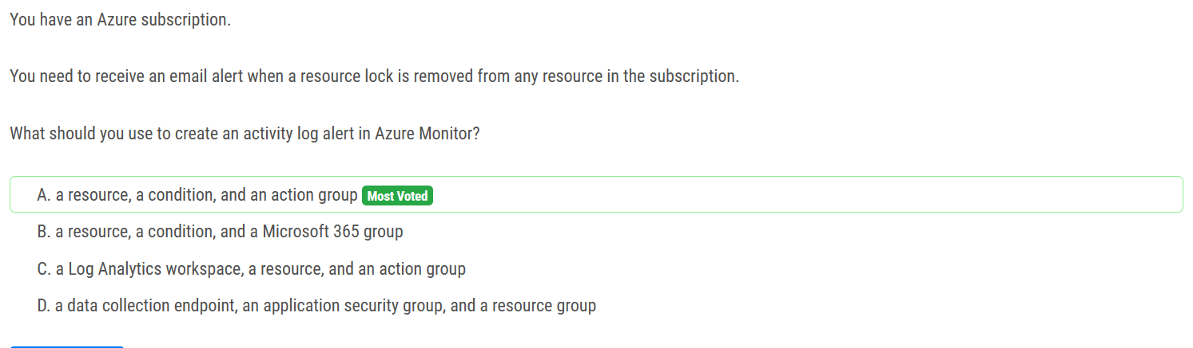

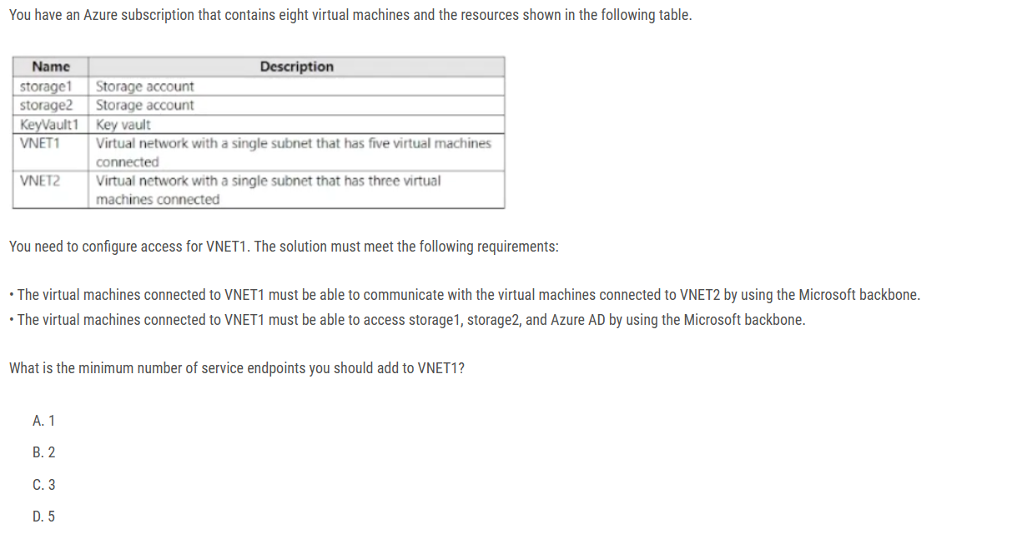

Ans: B ( 2 )

You create one Service Endpoint per Azure service per Vnet (Vnet-to-Vnet does not require nor can it be configured with service endpoints) Hence:

1 service endpoint for Vnet1 to Microsoft.Storage

1 service endpoint for Vnet1 to Microsoft.AzureActiveDirectory

When adding service endpoints on the VNET1 side you only get to choose the service ( Microsoft.Storage ) not the actual storage accounts. Once you add this service endpoint it can be then linked to on the storage side for both accounts.

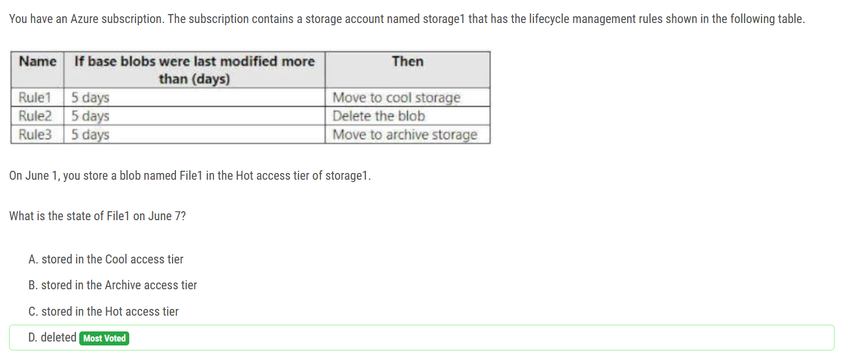

If you define more than one action on the same blob, lifecycle management applies the least expensive action to the blob. For example, action delete is cheaper than action tierToArchive. Action tierToArchive is cheaper than action tierToCool.

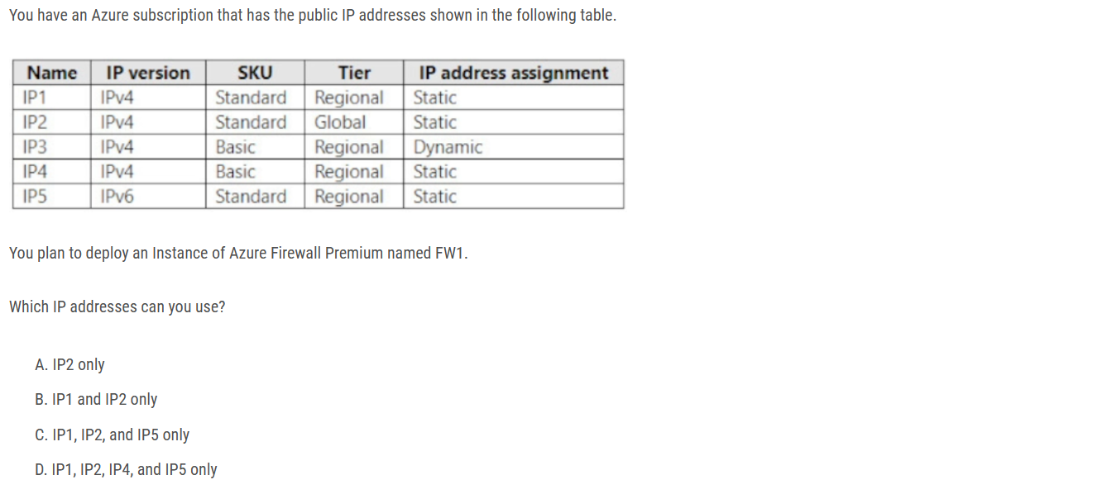

Answer B

Azure Firewall

- Dynamic IPv4: No

- Static IPv4: Yes

- Dynamic IPv6: No

- Static IPv6: No

Azure Firewall supports standard SKU public IP addresses. Basic SKU public IP address and public IP prefixes aren't supported.

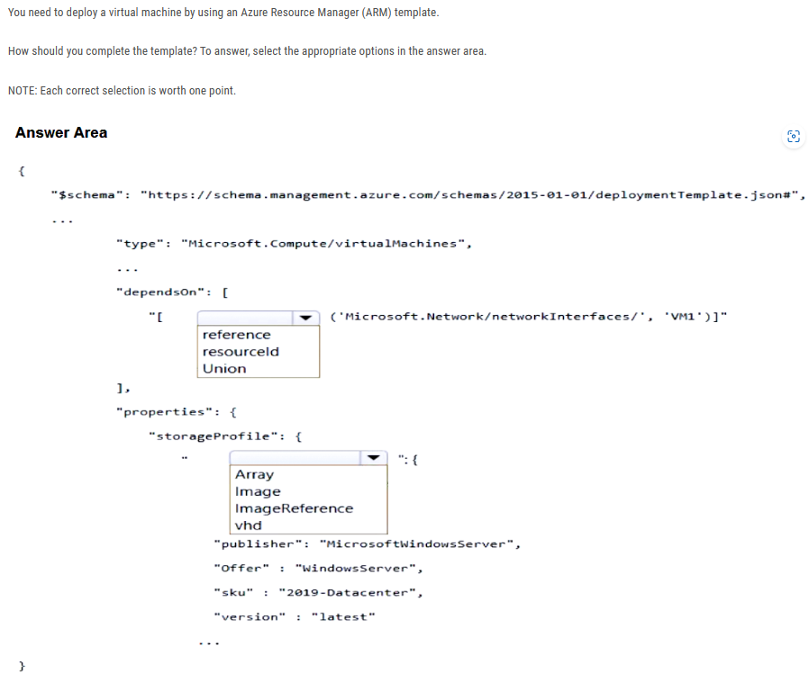

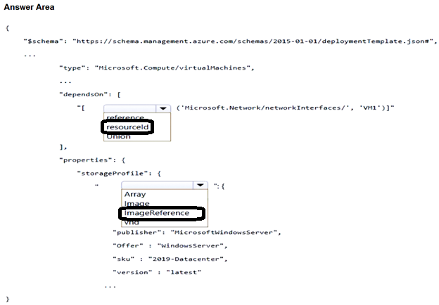

The dependsOn property specifies the resources that must be created before the virtual machine can be created. In this case, the virtual machine must depend on the network interface. The storageProfile property specifies the storage configuration for the virtual machine. In this case, the virtual machine will use an image from the Microsoft Windows Server image gallery.

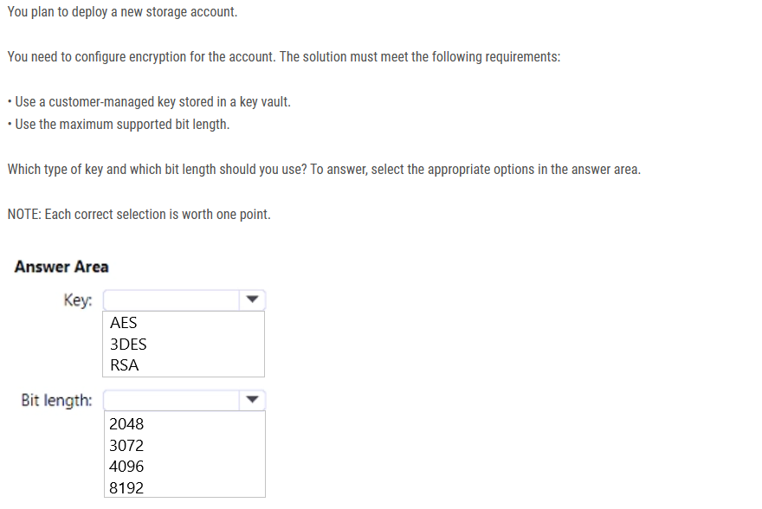

Ans: RSA 4096

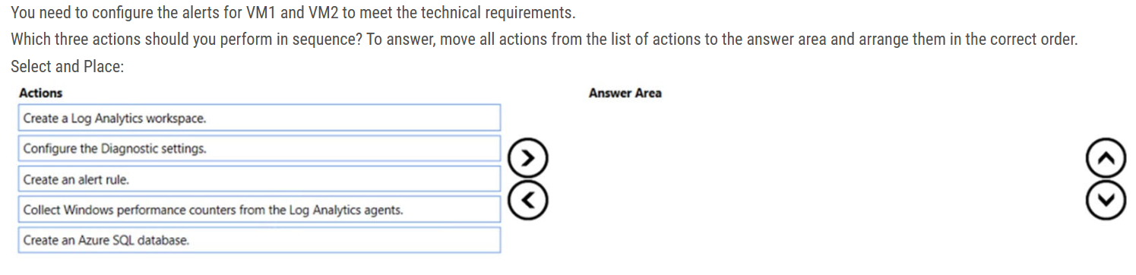

1. Create a log Analytics workspace.

2. Collect windows performance counters from the Log Analytics agents.

3. Create an alert rule.

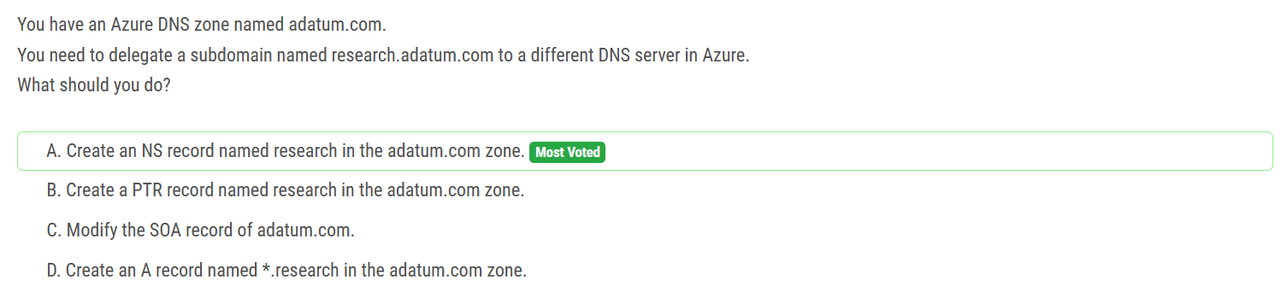

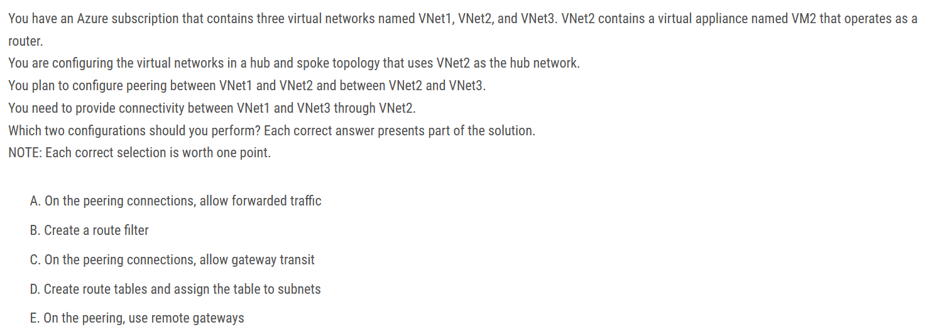

A and D should be the answer. There is no VPN gateway involved so no need for Allow Gateway Transit.

E is for VPN traffic forward

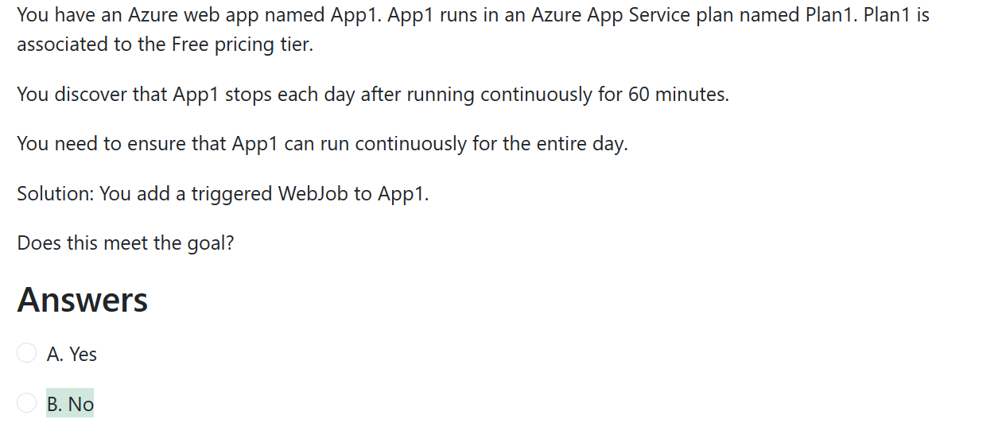

You need to change to Basic pricing Tier.

Note: The Free Tier provides 60 CPU minutes / day. This explains why App1 is stops. The Basic tier has no such cap.

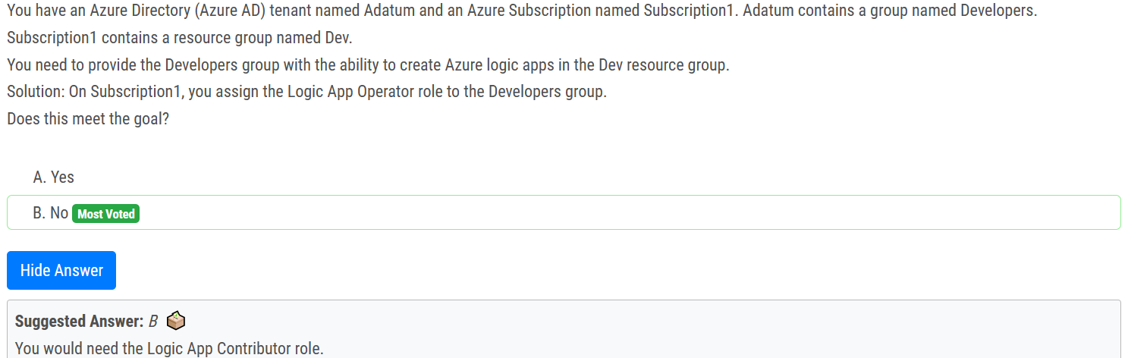

Logic App Operator - Lets you read, enable, and disable logic apps, but not edit or update them. Logic App Contributor - Lets you create, manage logic apps, but not access to them.

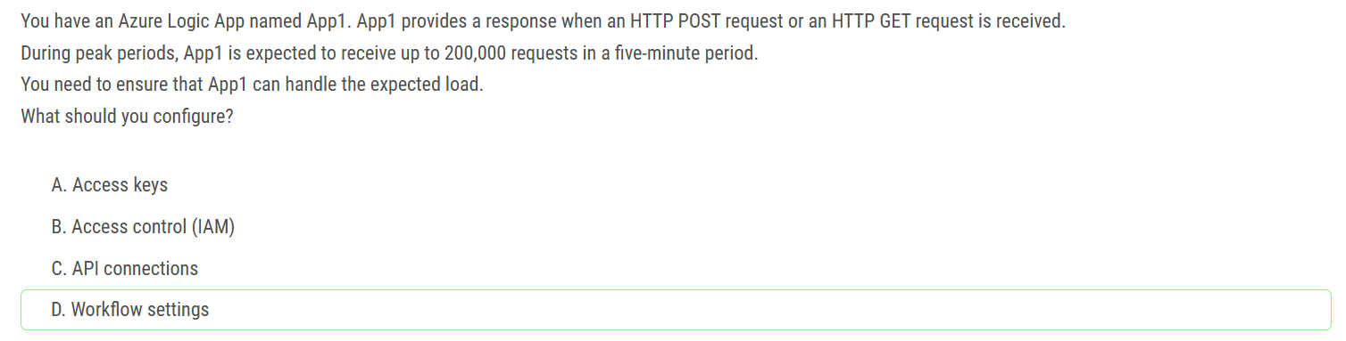

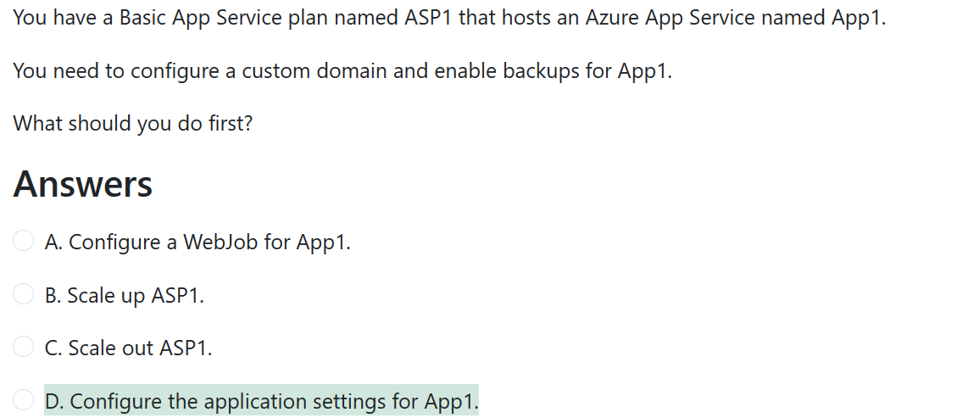

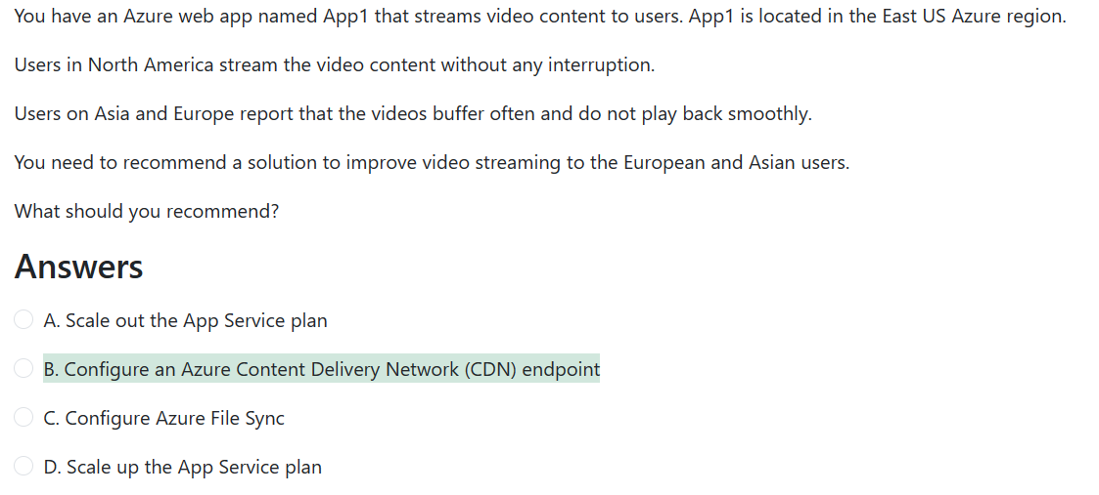

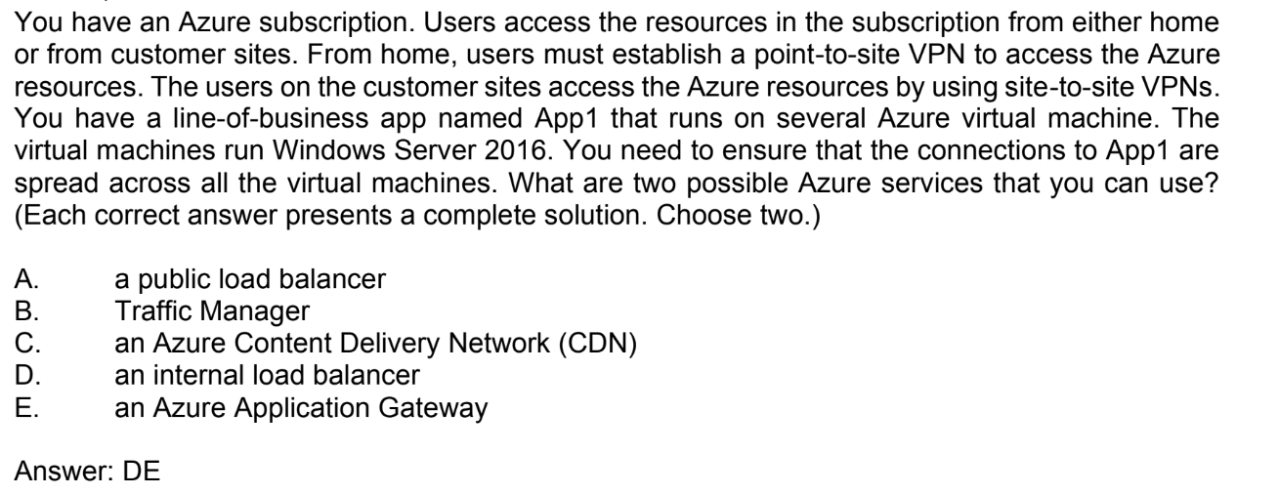

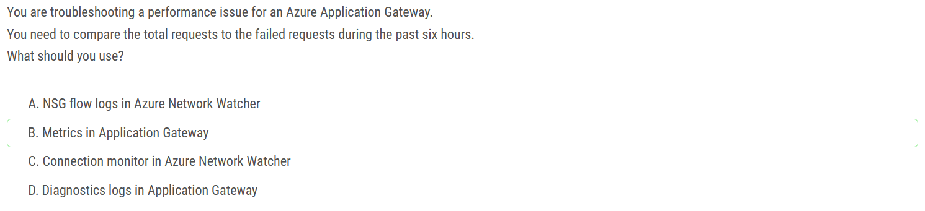

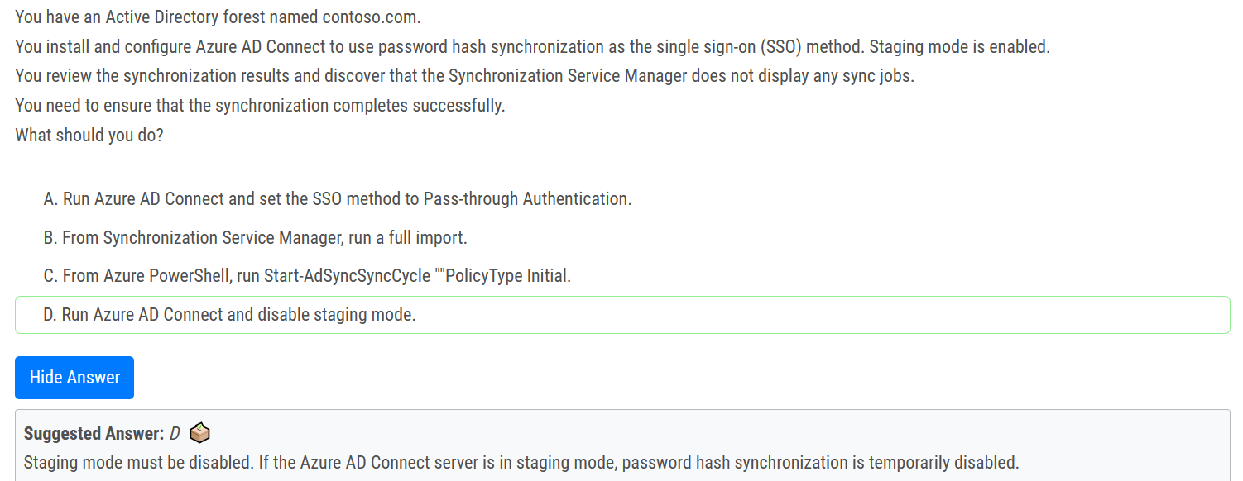

During installation, you can select the server to be in staging mode. This action makes the server active for import and synchronization, but it does not run any exports. A server in staging mode is not running password sync or password writeback, even if you selected these features during installation. When you disable staging mode, the server starts exporting, enables password sync, and enables password writeback

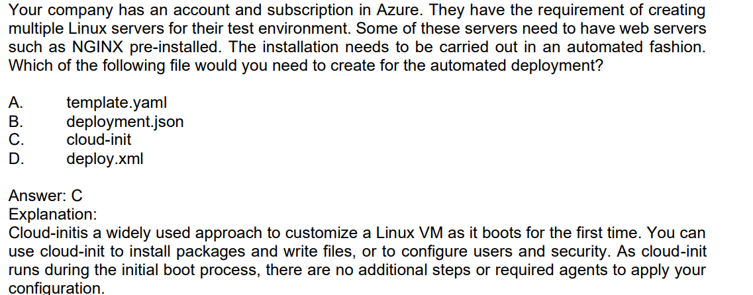

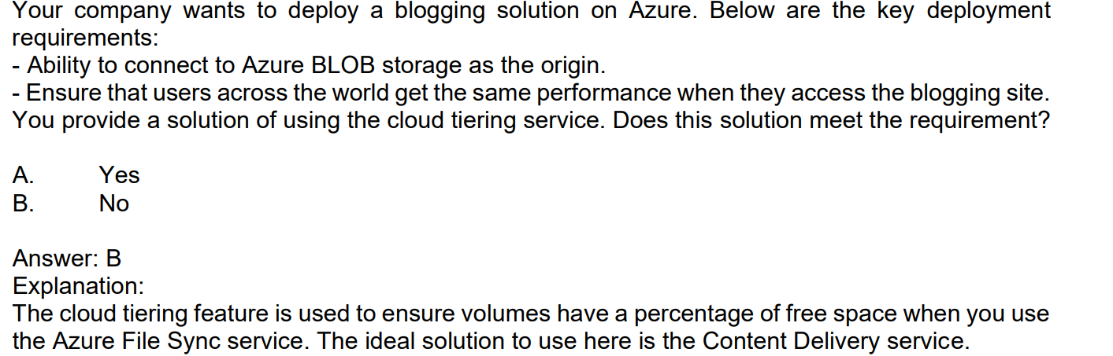

Cloud tiering, an optional feature of Azure File Sync, decreases the amount of local storage required while keeping the performance of an on-premises file server. When enabled, this feature stores only frequently accessed (hot) files on your local server.

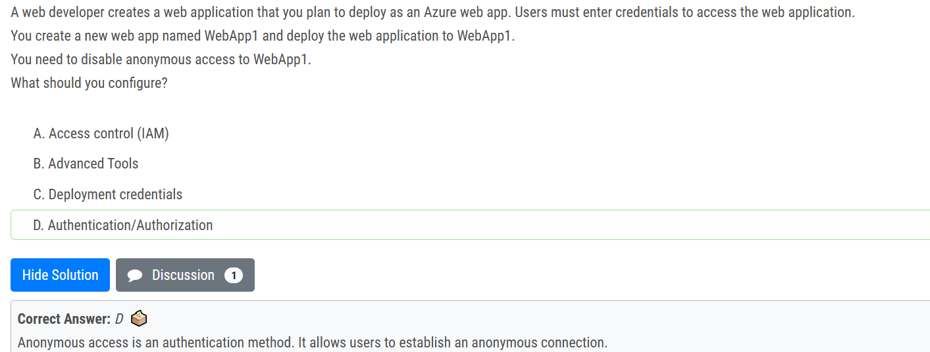

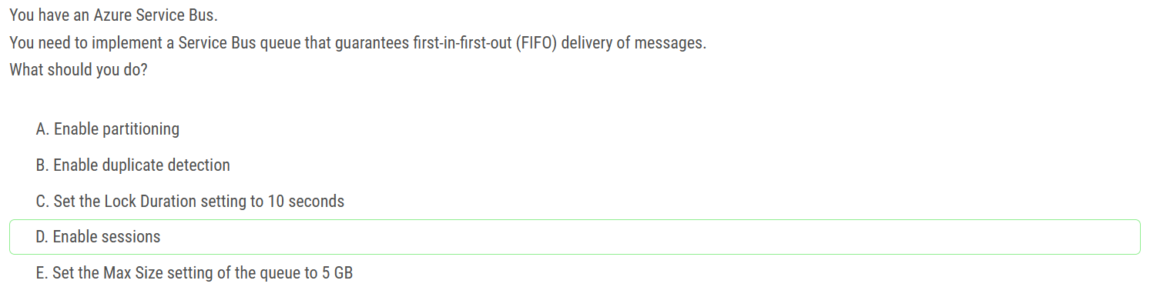

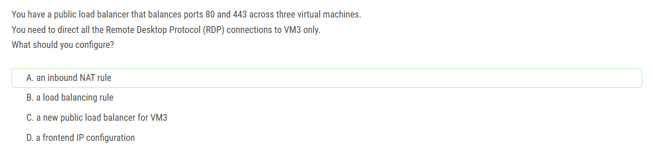

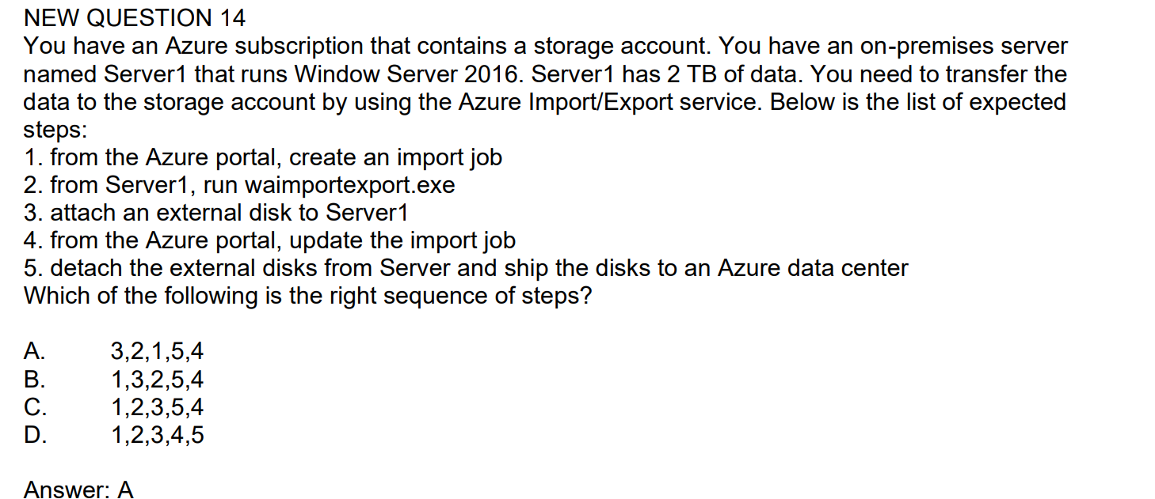

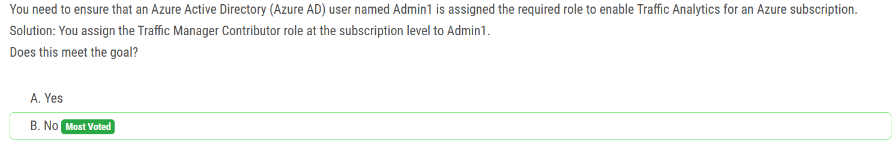

Q.36 Assign Network Contributor role at subscription level to Admin1 ◊ Yes

Q.37 Assign Owner role at subscription level to Admin1 ◊ Yes

Q.38 Assign Reader role at subscription level to Admin1 ◊ No

Q.52 Assign Traffic Manager Contributor role at subscription level to Admin1 ◊ No

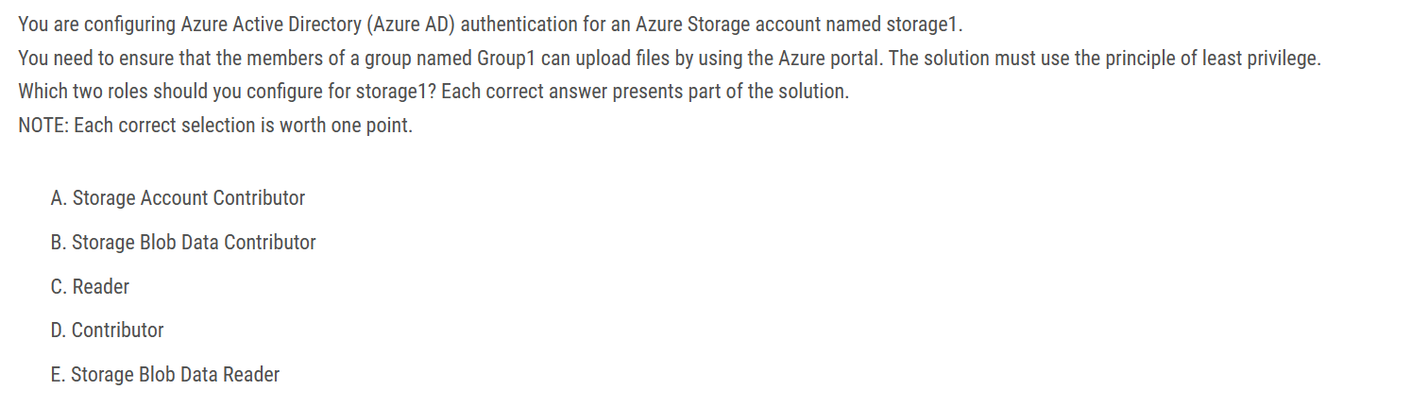

B) "Storage Blob Data Contributor" & C) "Reader"

The following line says it all: "The Reader role is an Azure Resource Manager role that permits users to view storage account resources, but not modify them. It does not provide read permissions to data in Azure Storage, but only to account management resources. The Reader role is necessary so that users can navigate to blob containers in the Azure portal. For example, if you assign the Storage Blob Data Contributor role to user Mary at the level of a container named sample-container, then Mary is granted read, write, and delete access to all of the blobs in that container. However, if Mary wants to view a blob in the Azure portal, then the Storage Blob Data Contributor role by itself will not provide sufficient permissions to navigate through the portal to the blob in order to view it. The additional permissions are required to navigate through the portal and view the other resources that are visible there."

The "Storage Blob Data Reader" doesn't let you see the storage account in the portal.

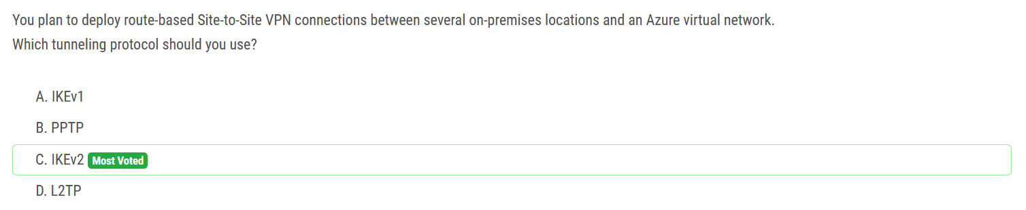

IKEv2 supports 10 S2S connections, while IKEv1 only supports 1.

key word "Route-Based" coz "Policy-based" only supports IKEv1.

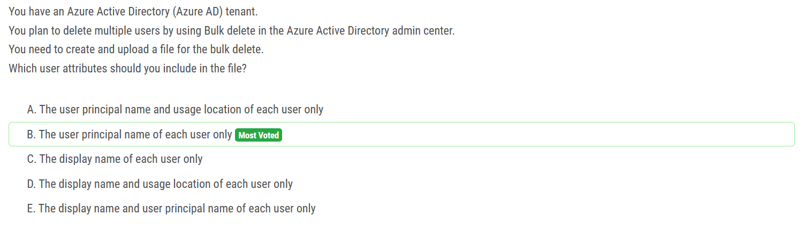

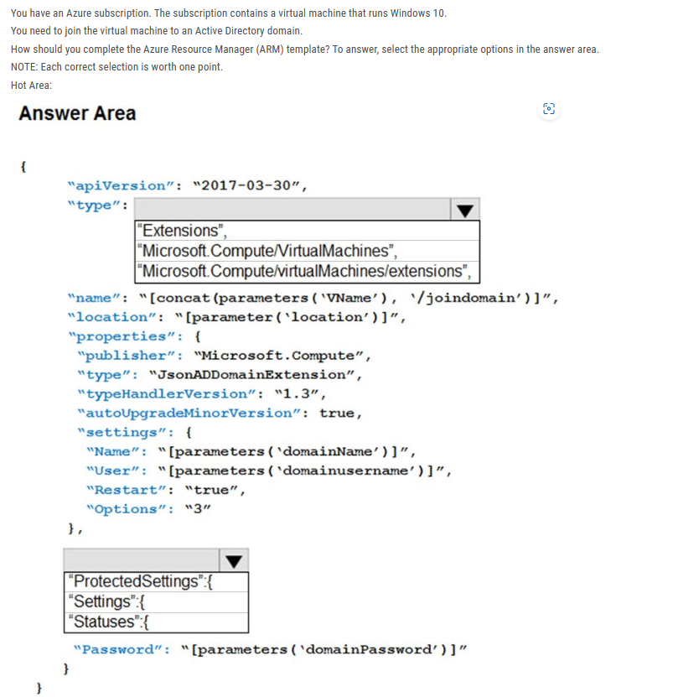

box1: Microsoft.Compute/virtualMachines/extensions

box2: protectedSettings

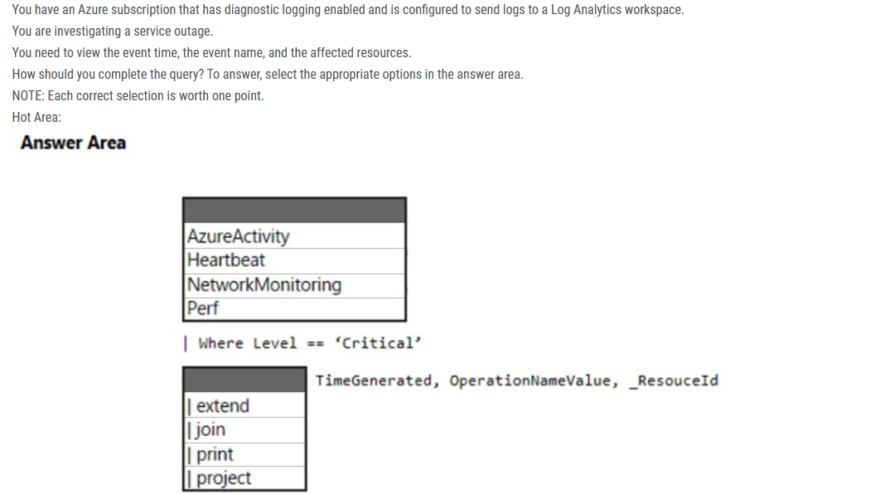

Box 1: AzureActivity -

Box 2: | project -

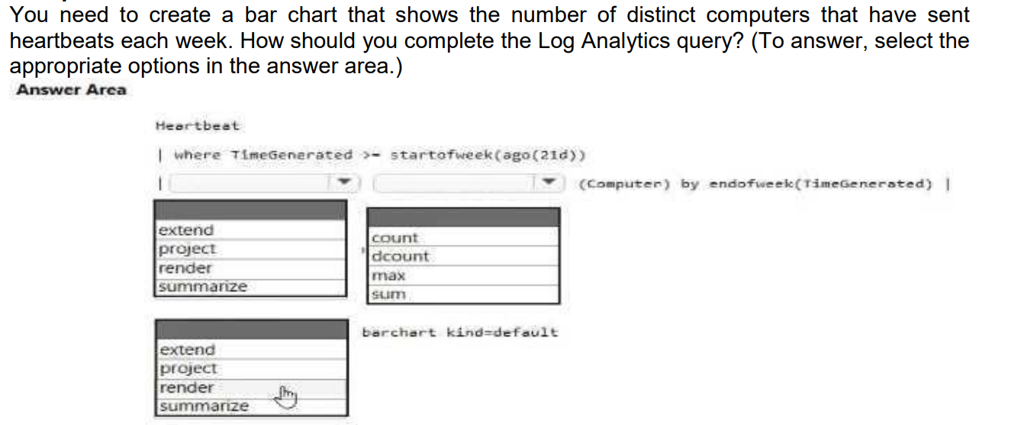

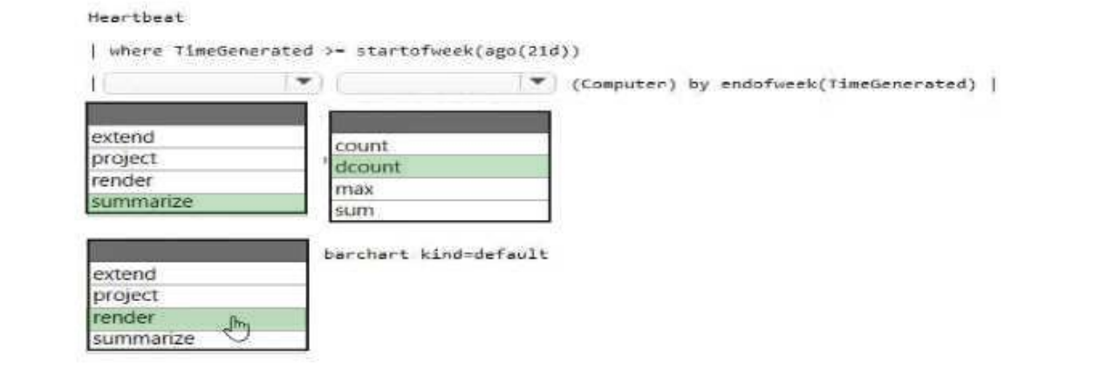

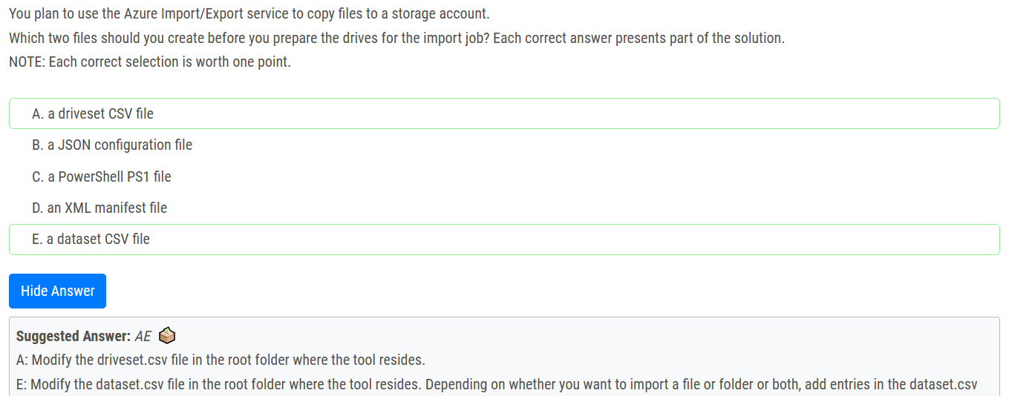

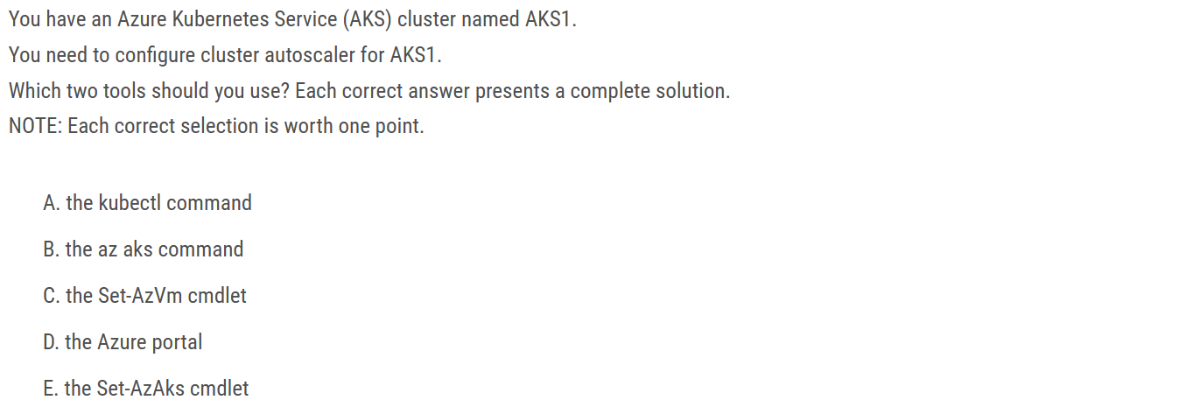

Correct Answer: B and D

We need to configure autoscaler for the AKS cluster. We do not want to scale Kubernetes pods, so kubectl command is not needed.

A: kubectl command is used for configuring Kubernetes and not AKS cluster.

B: The az aks command is used for the AKS cluster configuration.

C: Set-AzVm cmdlet is used for VMs.

D: Azure portal, under node pools, press scale, then choose auto scale.

E: Set-AzAks, creates or updates an AKS cluster, the correct cmdlet is Set-AzAksCluster.

AKS clusters can scale in one of two ways:

- The cluster autoscaler watches for pods that can't be scheduled on nodes because of resource constraints. The cluster then automatically increases the number of nodes.

- The horizontal pod autoscaler uses the Metrics Server in a Kubernetes cluster to monitor the resource demand of pods. If an application needs more resources, the number of pods is automatically increased to meet the demand.

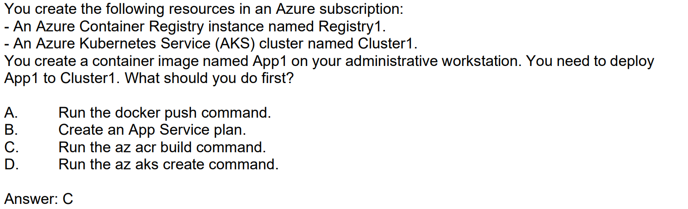

az acr build will build and push the image at the same time. Queues a quick build, providing streaming logs for an Azure Container Registry.

docker build/push will do the same thing, but you will have to configure docker to login to the container registry.

Note: If answer C is missing from the exam, then select A.

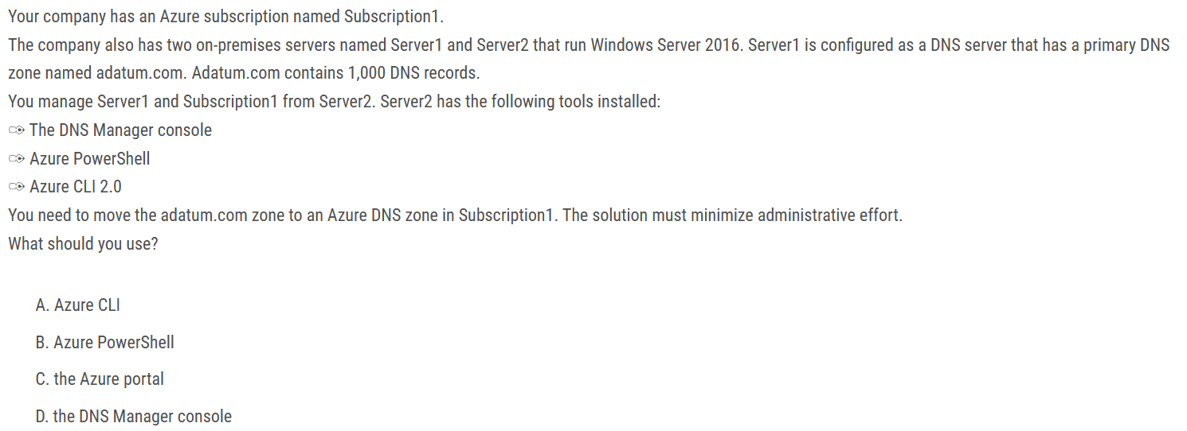

Answer is Azure CLI

Azure DNS supports importing and exporting zone files by using the Azure command-line interface (CLI). Zone file import is not currently supported via Azure PowerShell or the Azure portal.

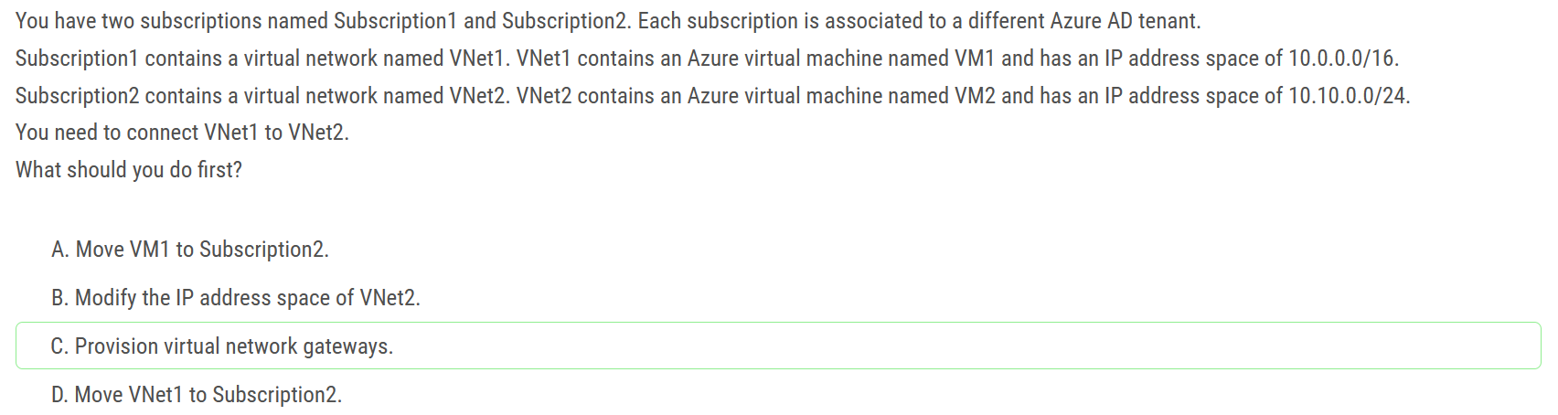

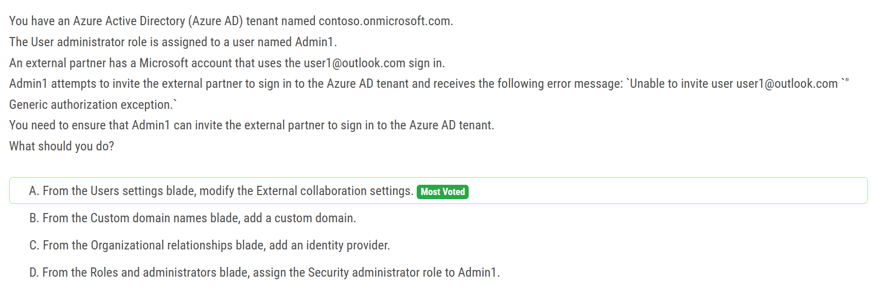

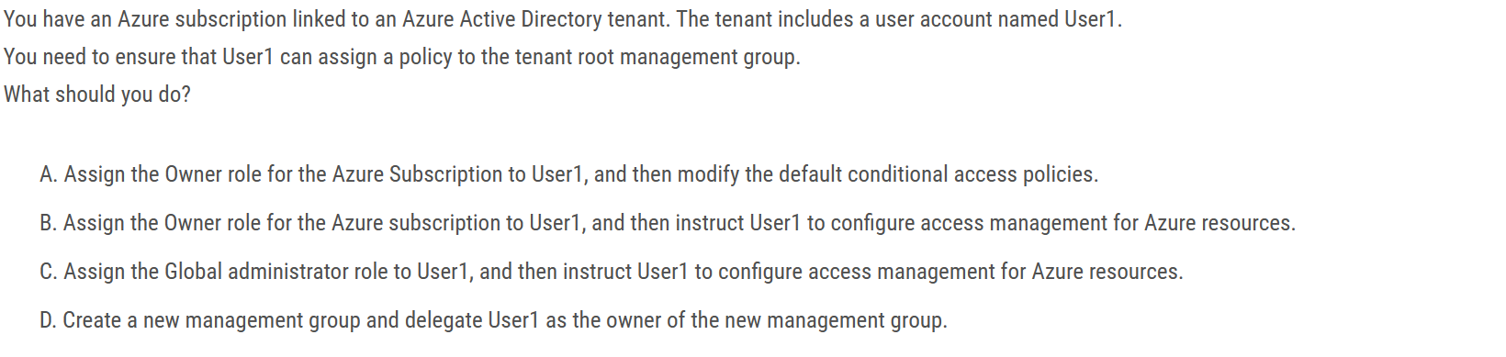

Ans C

Assigning someone as Owner to a Subscription gives them full control ONLY to that subscription. The question requires that the person touches the Root Management Group. Only an AAD Global Administrator has the permissions to do so. So answer is C.

No one is given default access to the root management group. Azure AD Global Administrators are the only users that can elevate themselves to gain access. Once they have access to the root management group, the global administrators can assign any Azure role to other users to manage it.

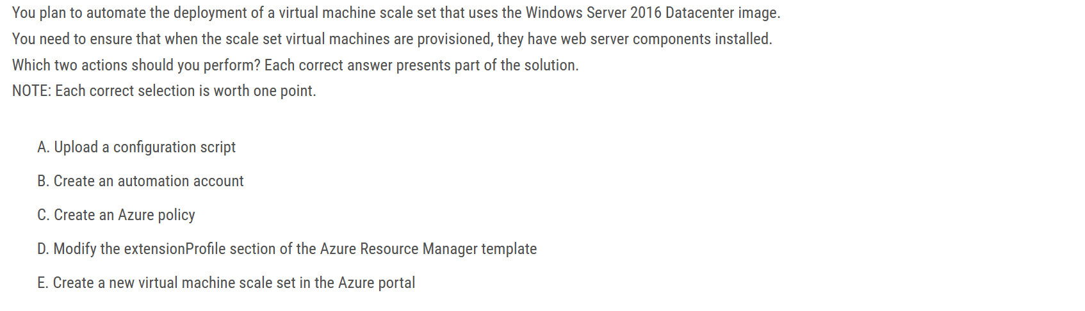

Correct Answer: A and D

because of the word "automate" you can't use the portal.

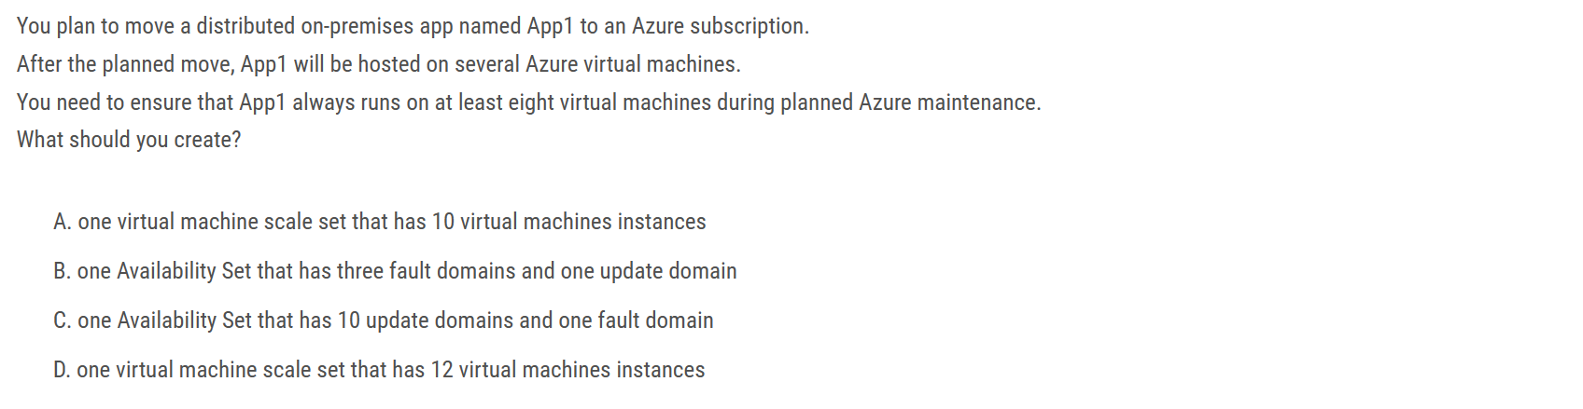

The correct Answer is A.

First: in case you created one fault domain, you are limited with one update domain. You can test this.

Second: By default, Azure uses 5 update domains and up to 3 fault domains. So, In case you created 10 vm in scale set. then you will have 2 vm in each update domain. So once one update domain is not available, then you get 4 domains with 8 vms as required.

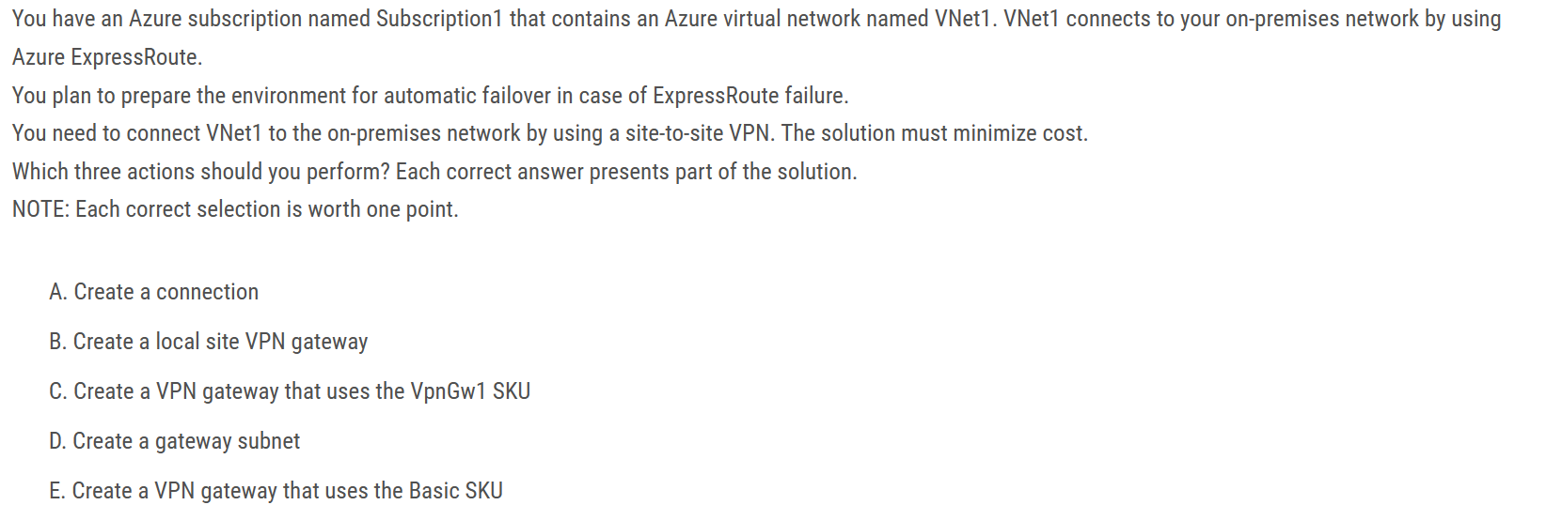

Correct Answer: A, B and C

For a site to site VPN, you need:

- a local gateway

- a gateway subnet

- a VPN gateway

- a connection to connect the local gateway and the VPN gateway

However, the question states that VNet1 connects to your on-premises network by using Azure ExpressRoute. For an ExpressRoute connection, VNET1 must already be configured with a gateway subnet so we don't need another one.

Note: BasicSKU cannot coexist with ExpressRoute. You must use a non-Basic SKU gateway for both the ExpressRoute gateway and the VPN gateway.

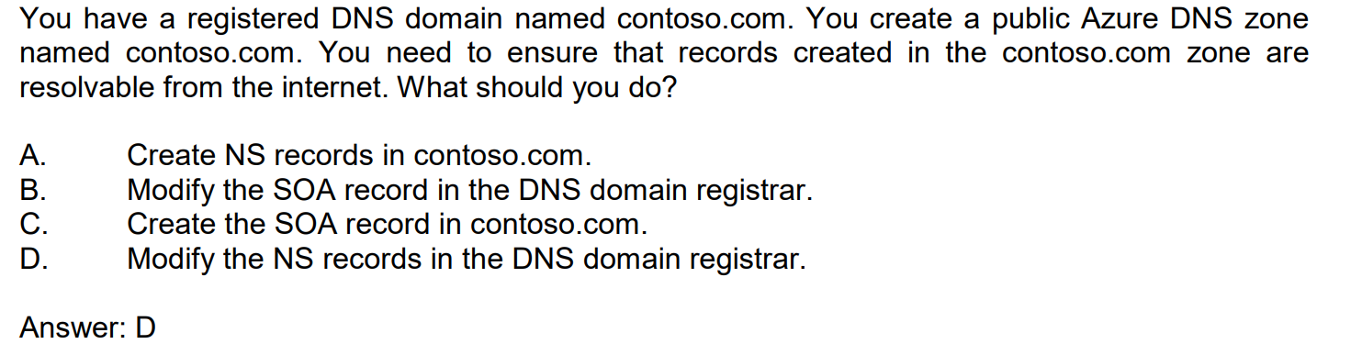

Registrar “owns” the tld and will have their NS registered against the domain by default. By changing the registrar NS records to point to your Azure DNS NS records you take ownership into your Azure DNS.

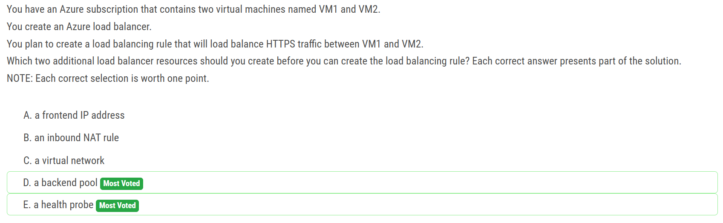

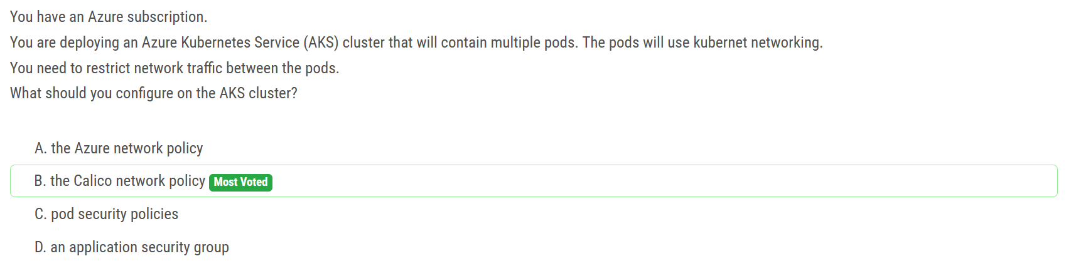

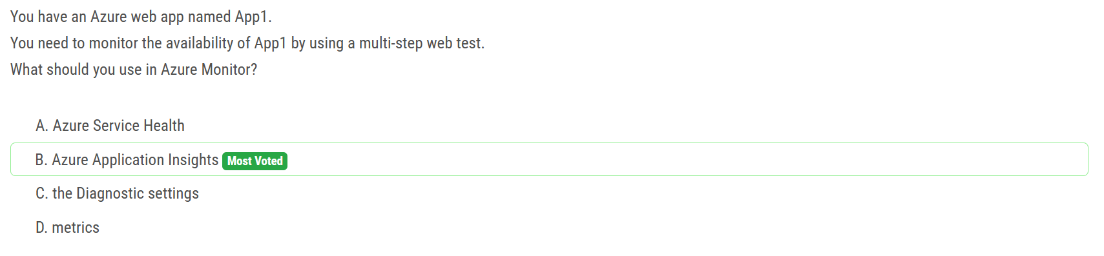

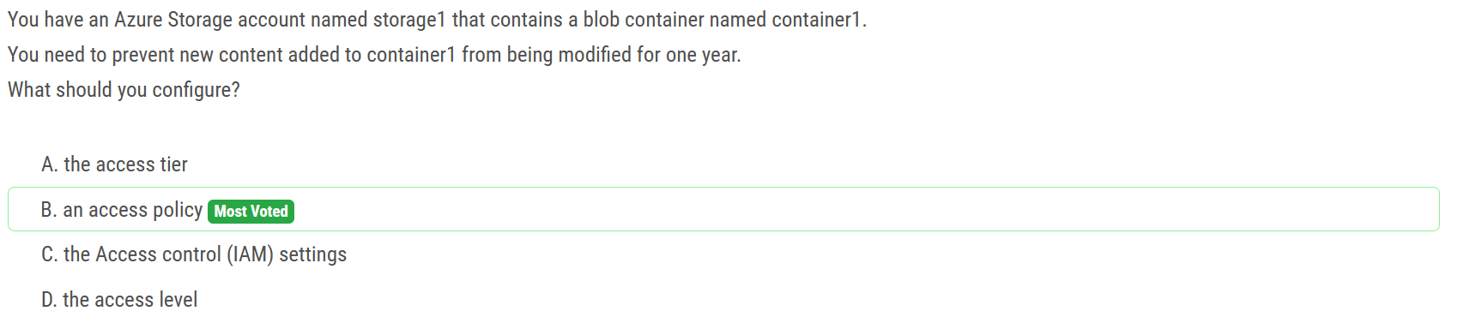

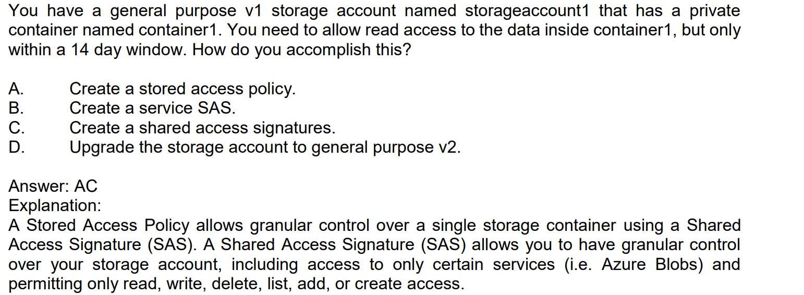

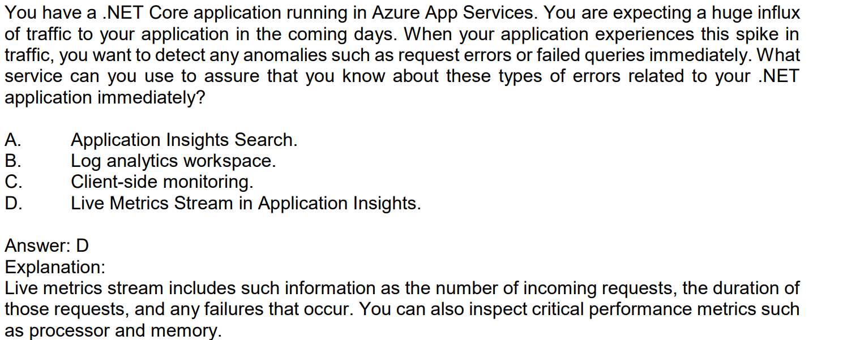

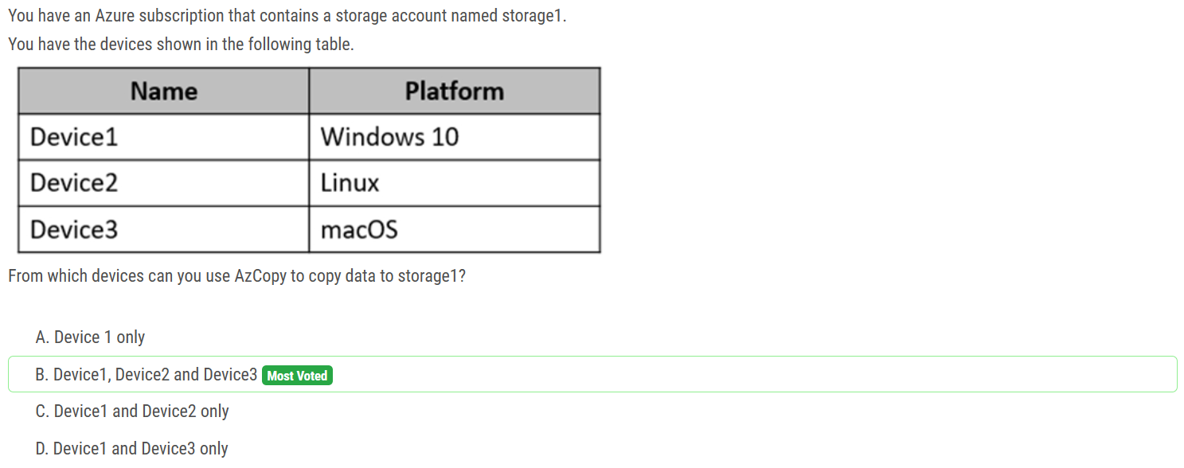

AzCopy works on all three OS,

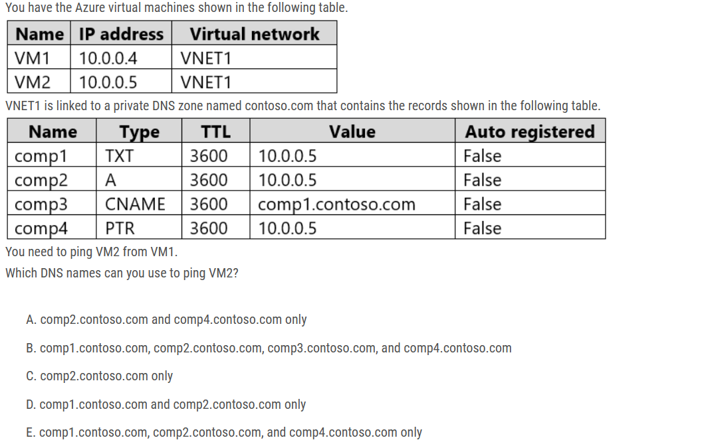

Ans : C

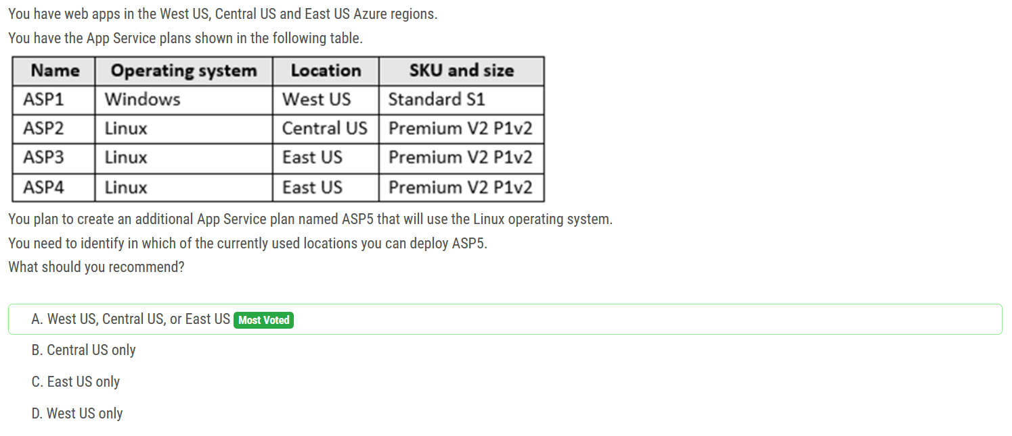

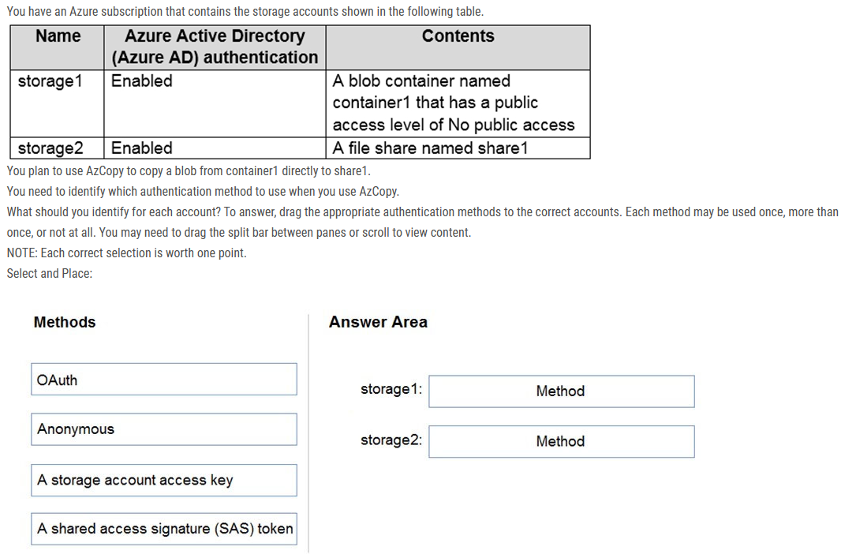

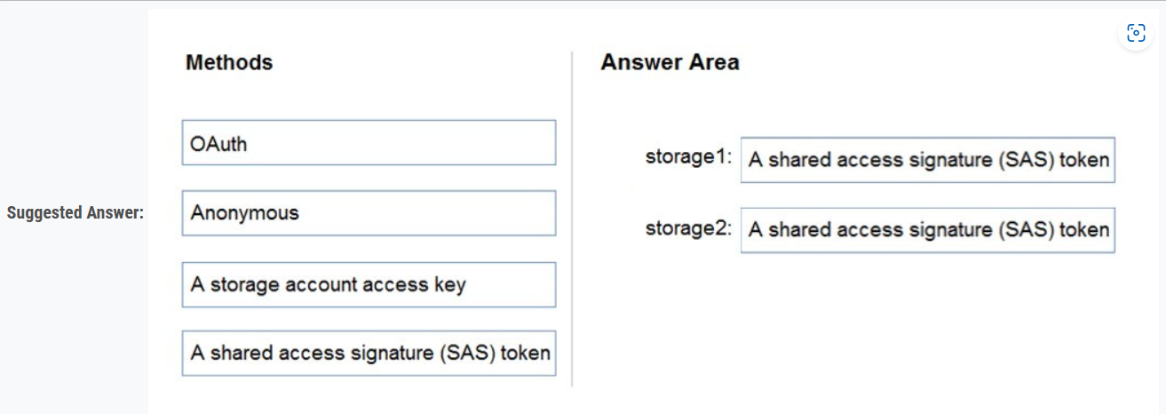

Blob Storage: Support both Azure Active Directory (AD) and Shared Access Signature (SAS) token.

File Storage: Only Shared Access Signature (SAS) token is supported.

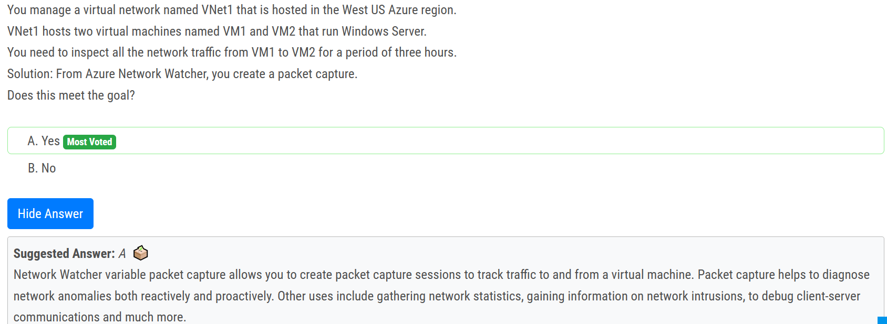

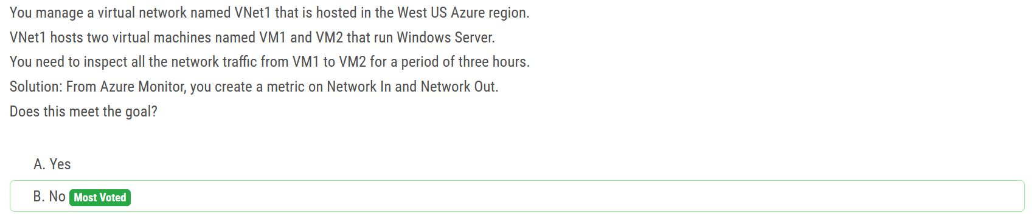

You use the Packet Capture, not Connection Monitor nor Network watcher

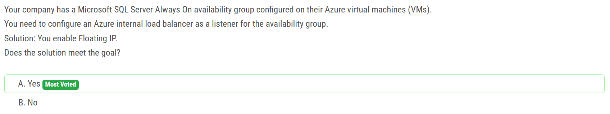

Yes, enabling Floating IP on the Azure internal load balancer as a listener for the availability group can meet the goal. By enabling Floating IP, the load balancer will use a floating IP address as the source IP address for outbound flows from the backend pool. This will ensure that the IP address used by the backend pool remains the same even if a VM is restarted or replaced, which is important for maintaining the listener for the availability group.

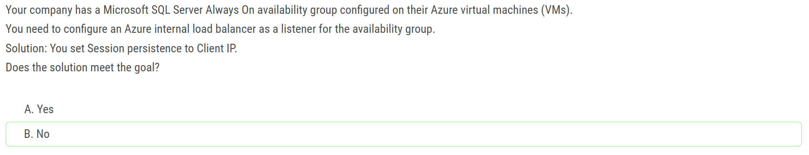

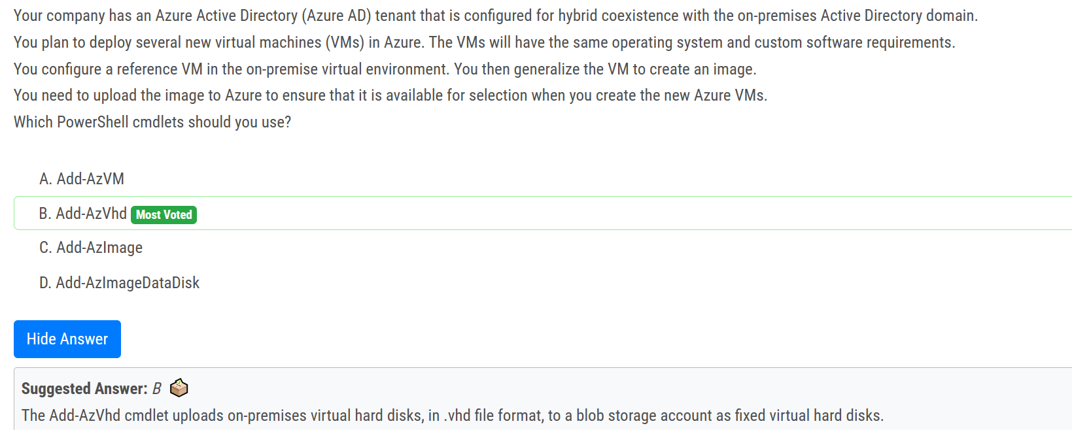

The **Add-AzVhd** cmdlet uploads an on-premise virtual hard disk to a managed disk or a blob storage account.

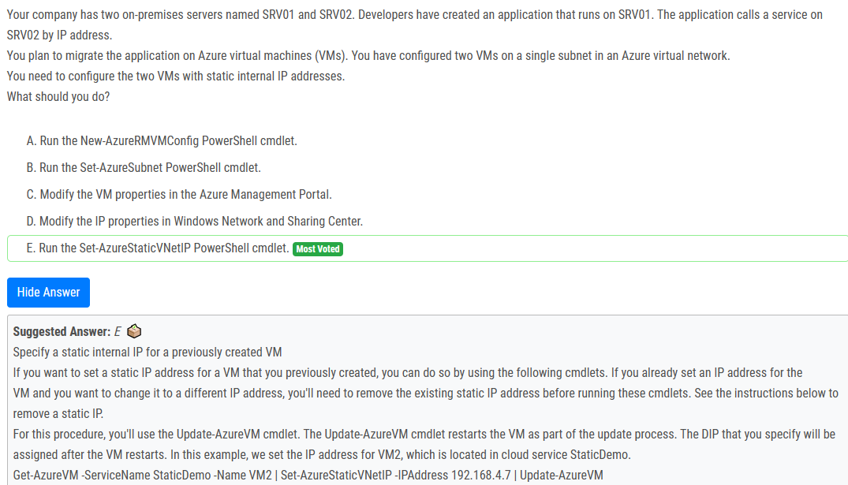

FYI: For the new PowerShell cmdlets you would use: Set-AzNetworkInterface

